**Project- Case Study on YouTube**

**Name- Ashutosh Ratnakar**

**Video link-**

[**https://drive.google.com/file/d/1wjXCKfnr9-JLFVT7baaLpPrC5WKNpRda/view?usp=drive_link**](https://drive.google.com/file/d/1wjXCKfnr9-JLFVT7baaLpPrC5WKNpRda/view?usp=drive_link)

**GitHub link-**

**Problem Statement**

**Product Dissection for top leading Platforms**

Welcome to this case study on dissecting and designing products for top leading platforms. In this case study, you will delve into the intriguing world of schema design for a prominent platform of your choice. Your task is to choose a top leading platform, research its features, and meticulously craft a schema design that encapsulates the essence of its functionality. By focusing on key entities, attributes, and relationships, you will gain invaluable insights into how data architecture drives the platform's effectiveness.

**Step 1: Choose a Leading Platform**

Select a leading platform of your choice, which could span various domains such as social media, e-commerce, finance, or any other industry. This choice will form the foundation of your exploration into its schema design.

**Step 2: Research:**

Thoroughly research the platform you have selected. Investigate its core features, functionalities, and user interactions. Identify the top features that define its user experience and contribute significantly to its popularity.

**Step 3: Product Dissection and Real-World Problems solved by the platform**

In this step, you will meticulously analyse the platform's standout features and how they provide innovative solutions to real-world challenges. By identifying key functionalities that resonate with users, you'll unravel how the platform effectively addresses problems and enhances user experiences. This dissection will serve as the foundation for understanding how the schema design aligns with the platform's core objectives.

**Step 4: Case Study on the real-world problems and approach to solving them**

In this pivotal step, you will expand on the real-world challenges uncovered in Step 3 through a comprehensive case study. Delve into specific instances where users encountered difficulties and showcase how the platform's unique features provided effective solutions. By dissecting the approach taken by the platform to overcome these challenges, you'll gain a deeper appreciation for the platform's user-centric design philosophy and how it shapes the schema design.

**Step 5: Schema Design Based on Top Features**

Based on the features you have identified, craft a schema design that reflects the platform's data structure. Focus on the key entities, attributes, and relationships that underpin the chosen features. Your schema should capture the essence of how the platform organises and utilizes its data.

**Step 6: Rationale Behind the Design**

While creating the schema design, consider the rationale behind the platform's choices. Reflect on why certain entities and relationships were chosen and how they align with the platform's goals. This will help you understand the strategic decisions driving the schema's architecture.

**Step 7: Create an ER Diagram**

Utilize tools like the Miro platform or similar applications to create an illustrative Entity-Relationship (ER) diagram. This diagram should vividly depict the entities, attributes, and relationships present within your schema design. The ER diagram will serve as a visual representation of your insights.

**Step 8: Presentation of Findings**

Present your findings in a clear and concise manner. Showcase your understanding of how the schema design impacts the platform's functionality and user experience. Explain how your chosen features are integrated into the schema and how the schema's structure supports the platform's objectives.

**Task Details:**

1. **Answer Submission:** Your submission should include well-structured solutions for all provided questions related to product schema designs.
2. **Video Creation:** Create an informative and engaging video where you thoroughly explain the Case Study.
3. **Depth and Clarity:** Ensure your solutions are detailed and showcase your understanding of product schema design principles. Similarly, in the video, provide clear explanations that are easy to understand for a wide audience.
4. **Creativity Encouraged:** You are welcome to utilize visuals, diagrams, or creative elements to enhance the clarity and impact of your explanations.

**Note:**

1. Duplicate this document and proceed to write your solutions and prepare your video.
2. Include the video link in this document before final submission.

Best of luck in completing this project and showcasing your prowess in dissecting and designing product schema for leading platforms!

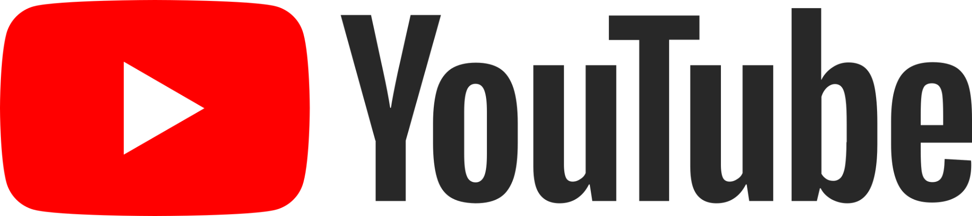

**Product Dissection for YouTube**

### **Company Overview:**

YouTube is a popular online video-sharing platform that was founded in February 2005. It allows users to upload, share, and view videos on a wide range of topics. The company was created by three former PayPal employees, Chad Hurley, Steve Chen, and Jawed Karim, and was later acquired by Google in November 2006. Since then, YouTube has grown exponentially and has become the go-to platform for video content.

### **Product Dissection and Real-World Problems Solved by YouTube:**

YouTube, a global video-sharing platform, has effectively addressed real-world challenges through its innovative product offerings. With a focus on video content, YouTube empowers users to create, share, and engage with a wide range of videos, bridging the gap between content creators and viewers. By providing a platform for video distribution and consumption, YouTube solves the problem of content accessibility and democratizes video production and distribution.

One of the key challenges YouTube solves is content distribution. Prior to YouTube, traditional broadcast channels had significant control over what content was aired, limiting the opportunities for aspiring content creators to reach a wider audience. YouTube's platform allows anyone with an internet connection to upload and share videos, eliminating the need for gatekeepers and democratizing content distribution. This has enabled individuals, businesses, and organizations to share their stories, knowledge, and entertainment with a global audience.

YouTube also addresses the challenge of content accessibility. With the vast amount of videos available on the platform, users can easily find information, entertainment, and educational resources on a wide range of topics. This solves the problem of limited access to diverse content, as YouTube offers a library of videos that cater to various interests and preferences. Users can search for specific topics, explore trending videos, and discover new content creators, ensuring a rich and accessible video experience.

Furthermore, YouTube provides monetization opportunities for content creators, solving the problem of generating income from their videos. Through the YouTube Partner Program, creators can monetize their content through advertising, sponsorships, and other revenue streams. This has empowered individuals and businesses to turn their passion for video creation into a viable career or business opportunity, solving the challenge of monetizing video content effectively.

In conclusion, YouTube's product design has successfully tackled real-world problems by creating a platform that addresses content distribution, accessibility, and monetization challenges. By providing a space for content creators to share their videos with a global audience, YouTube has revolutionized the way we consume and engage with video content, empowering individuals and businesses to connect, learn, and entertain on a global scale.

### **Case Study: Real-World Problems and YouTube's Innovative Solutions**

YouTube, a leading video-sharing platform, has successfully addressed real-world challenges through its innovative solutions. By understanding user needs and leveraging technology, YouTube has become a go-to platform for video content, solving problems related to content distribution, accessibility, monetization, community building, and copyright infringement.

#### **Problem 1: Limited Content Distribution**

**Real-World Challenge:** Traditional broadcast channels had significant control over what content was aired, limiting the opportunities for aspiring content creators to reach a wider audience.

**YouTube's Solution:**

YouTube revolutionized content distribution by providing a platform where anyone with an internet connection could upload and share videos. This eliminated the need for gatekeepers, democratizing content distribution and providing opportunities for individuals and businesses to share their stories, knowledge, and entertainment with a global audience.

#### **Problem 2: Content Accessibility**

**Real-World Challenge:** Prior to YouTube, accessing diverse video content on specific topics was challenging, as traditional media channels had limited programming options.

**YouTube's Solution:**

YouTube solved the problem of content accessibility by offering a vast library of videos on various topics. Users can easily find information, entertainment, and educational resources by searching for specific topics, exploring trending videos, and discovering new content creators. This has made video content more accessible to a broader audience, empowering users to learn, explore, and engage with a wide range of video content.

#### **Problem 3: Monetization for Content Creators**

**Real-World Challenge:** Many content creators struggled to monetize their videos and turn their passion into a sustainable career or business opportunity.

**YouTube's Solution:**

YouTube's Partner Program provides content creators with various monetization options, including advertising, sponsorships, and channel memberships. This has enabled individuals and businesses to generate income from their videos, creating opportunities for content creators to pursue their passions full-time and invest in high-quality content production.

#### **Problem 4: Community Building**

**Real-World Challenge:** Building communities around specific interests and fostering engagement between content creators and viewers was challenging before YouTube.

**YouTube's Solution:**

YouTube's platform facilitates community building through comments, likes, and shares. Users can interact with content creators and other viewers, creating a sense of community and fostering engagement. This has allowed users to connect with like-minded individuals, share their thoughts and opinions, and build relationships within the YouTube community.

#### **Problem 5: Copyright Infringement**

**Real-World Challenge:** Protecting intellectual property and preventing copyright infringement is a significant concern for content creators and rights holders.

**YouTube's Solution:**

YouTube has implemented a robust Content ID system that scans uploaded videos and compares them against a vast database of copyrighted material. This system helps identify and manage copyrighted content, allowing content creators and rights holders to protect their intellectual property. YouTube also provides a process for reporting and resolving copyright infringement issues, ensuring that creators' rights are respected and protected.

#### **Conclusion:**

YouTube's innovative solutions have effectively addressed real-world problems related to content distribution, accessibility, monetization, community building, and copyright infringement. By providing a platform for video content, YouTube has revolutionized the way we consume and engage with videos, empowering content creators, and providing a rich and diverse video experience for users worldwide. Through its continuous innovation and user-centric approach, YouTube has solidified its position as a leader in the online video industry.

### **Top Features of YouTube:**

1. **Video Uploading and Sharing:** YouTube allows users to upload and share videos of various formats and lengths. This feature enables content creators to showcase their work and share it with a global audience.
2. **Video Playback and Streaming:** YouTube's video playback feature allows users to watch videos seamlessly, adjusting video quality based on their internet connection. Users can stream videos in real-time, ensuring a smooth viewing experience.
3. **Comments and Engagement**: YouTube encourages user interaction through comments. Viewers can leave comments on videos, fostering discussions and feedback. This feature promotes engagement between content creators and their audience.
4. **Subscription and Notifications:** Users can subscribe to channels they enjoy, receiving notifications whenever new videos are uploaded. This feature ensures that users stay updated with their favorite content creators and never miss new releases.
5. **Playlists:** YouTube's playlist feature allows users to curate and organize videos into thematic collections. Users can create playlists for personal use or share them with others, making it easier to find and watch related videos.
6. **Recommendation Algorithm:** YouTube's recommendation system suggests videos based on a user's viewing history, preferences, and trends. This feature helps users discover new content aligned with their interests, enhancing their video-watching experience.
7. **Monetization:** YouTube offers various monetization options for content creators, such as advertising, sponsorships, and channel memberships. This feature allows creators to generate income from their videos and turn their passion into a sustainable career or business opportunity.
8. **Live Streaming:** YouTube's live streaming feature enables content creators to broadcast events, performances, and live discussions in real-time. This feature encourages real-time engagement with viewers and expands the possibilities for interactive content.

### **Schema Description:**

The schema for YouTube involves multiple entities that represent different aspects of the platform. These entities include Users, Videos, Comments, Likes, Subscriptions, and more. Each entity has specific attributes that describe its properties and relationships with other entities.

**User Entity:**

Users are at the core of YouTube. The user entity contains information about each user:

* **User_ID (Primary Key)**: A unique identifier for each user.
* **User_name**: The chosen username for the user's account.
* **Email**: The user's email address for account-related communication.
* **Full_Name**: The user's full name as displayed on their profile.
* **Registration_Date**: The date when the user joined YouTube.

**Video Entity:**

Videos represent the content shared on the platform:

* **Video_ID(Primary Key):** A unique identifier for each video.
* **User_ID (Foreign Key referencing User Entity**): The user who uploaded the video.
* **Title**: The title of the video.
* **Description**: A brief description providing information about the video.
* **Thumbnail_URL**: The URL of the thumbnail representing the video.
* **Upload_Date**: The date when the video was uploaded.

**Comment Entity:**

Comments enable users to engage in conversations around videos:

* **Comment_ID (Primary Key)**: A unique identifier for each comment.
* **Video_ID (Foreign Key referencing Video Entity):** The video being commented on.
* **User_ID (Foreign Key referencing User Entity)**: The user who posted the comment.
* **Text**: The text of the comment.
* **Comment_Date**: The date when the comment was posted.

**Like Entity:**

Likes represent user appreciation for videos:

* **Like_ID (Primary Key):** A unique identifier for each like.
* **Video_ID (Foreign Key referencing Video Entity):** The video being liked.
* **User_ID (Foreign Key referencing User Entity):** The user who liked the post.
* **Like_Date:** The date when the like was registered.

**Subscription Entity:**

Subscriptions establish connections between users:

* **Subscription_ID (Primary Key)**: A unique identifier for each subscription relationship.
* **Subscriber_User_ID(Foreign Key refer User Entity)**: The user who is subscribing.
* **Channel_User_ID (Foreign Key refer User Entity)**: The user who is subscribing.
* **Subscription_Date**: The date when the subscription relationship was initiated.

**Playlist Entity:**

Playlists allow users to curate and organize videos into thematic collections:

* **Playlist_ID (Primary Key):** A unique identifier for each playlist.
* **User_ID (Foreign Key referencing User Entity)**: The user who created the playlist.
* **Title:** The title of the playlist.
* **Description:** A brief description providing information about the playlist.
* **Creation_Date**: The date when the playlist was created.

**View Entity:**

Views represent the number of times a video has been watched:

* **View_ID (Primary Key)**: A unique identifier for each view.
* **Video_ID (Foreign Key referencing Video Entity)**: The video being viewed.
* **User_ID (Foreign Key referencing User Entity)**: The user who watched the video.
* **Ad_ID (Foreign Key referencing Advertisement Entity)**: A unique identifier for each advertisement.

**Advertisement Entity:**

Advertisements are displayed on YouTube for monetization purposes:

* **Ad_ID (Primary Key)**: A unique identifier for each advertisement.
* **Advertiser_ID** : The identifier for the advertiser associated with the ad.
* **Video_ID (Foreign Key referencing Video Entity)**: The video the ad is displayed on.

**Relationships are:**

* **Users upload Videos –** Each user can upload multiple videos.
* **Users comment on Videos –** Users can comment on multiple videos, and each video can have multiple comments.
* **Users like Videos –** Users can like multiple videos, and each video can have multiple likes.
* **Users subscribe to channels –** Users can subscribe to multiple channels and be subscribed to by multiple users.
* **Users create Playlists –** Each user can create multiple playlists.
* **Playlists contain Videos –** Each playlist can contain multiple videos, and each video can be part of multiple playlists.
* **Users watch Videos –** Users can watch multiple videos, and each video can be watched by multiple users.
* **Videos display Advertisements –** Each video can display multiple advertisements, and each advertisement is associated with a single video.
* **Advertisers create Advertisements –** Each advertiser can create multiple advertisements.

**ER Diagram:**

Let's construct an ER diagram that vividly portrays the relationships and attributes of the entities within the YouTube schema. This ER diagram will serve as a visual representation, shedding light on the pivotal components of YouTube's data model. By employing this diagram, you'll gain a clearer grasp of the intricate interactions and connections that define the platform's dynamics.

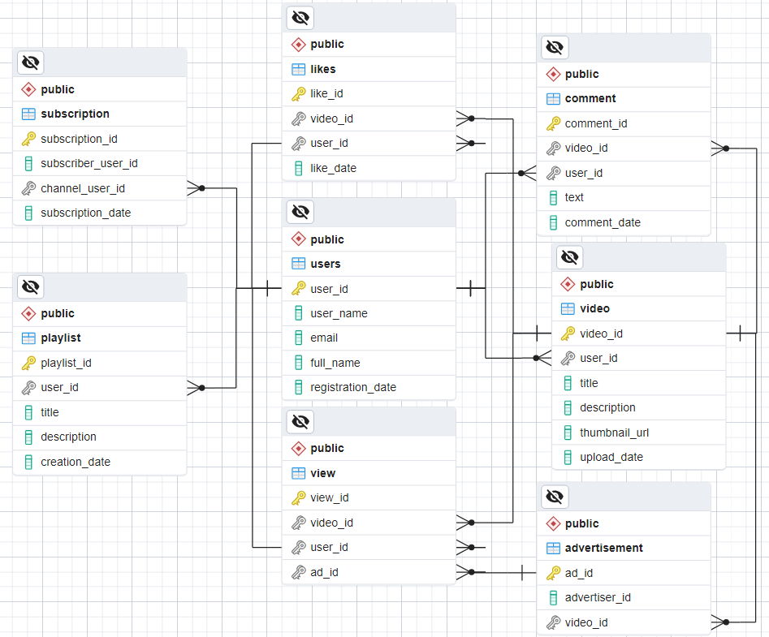

### 

### **Conclusion**

In this case study, we delved into the design of YouTube's schema and Entity-Relationship diagram. YouTube has revolutionized the way we consume video content by providing a platform for content creators to share their videos with a global audience. It has successfully solved real-world problems related to content distribution, accessibility, monetization, and community building. With its innovative features and constant evolution, YouTube continues to be a dominant force in the online video industry.